Exponential function Unit Test
Name:

Section A: Selected Response. Place the UPPER-CASE letter corresponding to the correct answer in the space provided. (10 points)

______1. Which of the following is true about the function y=0.75${(0.4)}^{x}$ ?

- Growing exponentially with an initial value of 0.75
- Growing exponentially with an initial value of 0.4
- Decaying exponentially with an initial value of 0.75
- Decaying exponentially with an initial value of 0.4

______2. Solve for $3^{4x}=9^{5x+1}$

- -1 b)$-\frac{1}{3}$ c)$-\frac{1}{6}$ d)$-\frac{3}{11}$

______3. Solve for ${10}^{-2}\left({10}^{1}+{10}^{0}\right)=$

- ${10}^{-2}$ b)$1.1$ c)$0.1$ d)$10$

______4. What of the following functions represents f(x)=$9^{x}$ after a reflection on the x-axis and a vertical translation 3 units up?

- $y=-(9^{x-3})$ b)$y=-\left(9^{x}\right)-3$ c)$y=9^{-x+3}$ d)$y=-\left(9^{x}\right)+3$

______5. An antique was worth $1500 in 1980 and has been increasing in value by 9% every year. What is the total value of the antique in 2005?

- y=1500${(0.09)}^{25}$ b) y=1500${(0.01)}^{25}$ c) y=1500${(1.09)}^{25}$ d) y=1500${(0.91)}^{25}$

______6. What is the equation of the horizontal asymptote of the function y=2${(3)}^{x}-$ 4 ?

- x=2 b) y=2 c) x= $-$4 d) y= $-$4

______7. Which set of properties does the function y=$3^{x}$ have?

- No x-intercept, no y-intercept
- No x-intercept, y-intercept is 1
- x-intercept is 1, no y-intercept
- x-intercept is 0, y-intercept is 0

______8. A colony of ants has an initial population of 750 and triples every day. Which function can be used to model the ant population, p, after t days?

- P(t)= 3${(750)}^{t}$ b) P(t)= $\frac{1}{3}{(750)}^{t}$ c) P(t)= 750${(\frac{1}{3})}^{t}$ d) P(t)= 750${(3)}^{t}$
______9. The equation of 10${(\frac{1}{5})}^{n}$ can also be written as:
- a= 5${(5)}^{n}$ b) a= $5{(5)}^{-n}$ c) a= $10{(5)}^{n}$ d) a= $10{(5)}^{-n}$

______10. For the exponential function y=10${(\frac{1}{5})}^{n}$, which of the following statement is not true?

- The graph of the function is decreasing
- The domain of the function is x$ϵR$
- The graph of the function is increasing
- The range of the function is y$>0$

Section B: Open Response. (Show all your work in the space provided.)

1. Solve for the variable in each of the following: (3 points each)

a) $8^{x+2 }={32}^{(x+1)}$ b)$3^{4x }={27}^{(x+5)}$ c) ${(\frac{1}{4})}^{x-5} -5=3$ d) ${(\frac{1}{27})}^{3x} ∙3=$ $9^{x+1}$

2. Wilson knows that his investment of $2000 will double every ten years in an account that compounds interest annually. He assumes that his investment will be worth $3000 in 5 years. Is his assumption correct? Explain. (3 points)

3. Ryan and Rachel have bought a home for $400 500 in Vancouver. The real estate agent informs them that homes in the area have generally increased by 2% every 5 years. Based on this, how should they be able to sell their home for in 12 years? (3 points)

Section C: Characteristics and Transformation of exponential function
1)
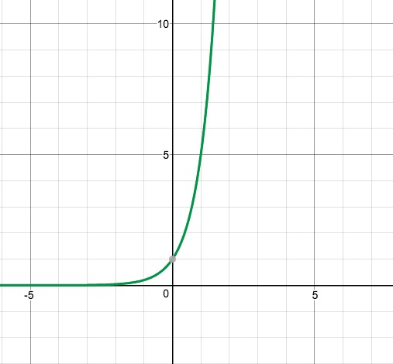
Look at the graph of exponential function, and identify all the following1 characteristics: (8 points)
- y=$5^{x}$
Domain:
Range:
y-intercept:
x-intercept:
Horizontal asymptote:
Increasing or decreasing?
Exponential growth or exponential decay?

- y=${ 4 (\frac{1}{2})}^{x}-2$
Domain:
Range:
y-intercept:
x-intercept:
Horizontal asymptote:
Increasing or decreasing?
Exponential growth or exponential decay?
Describe the transformation of the function when compared to the function of $y={(\frac{1}{2})}^{x}$

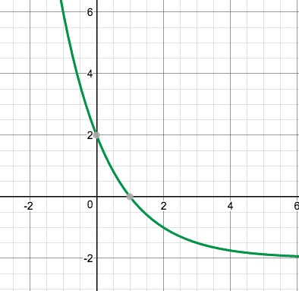

2) Sketch the following two graphs (6 points)

- y=$({\frac{1}{2})}^{x-3}-2$

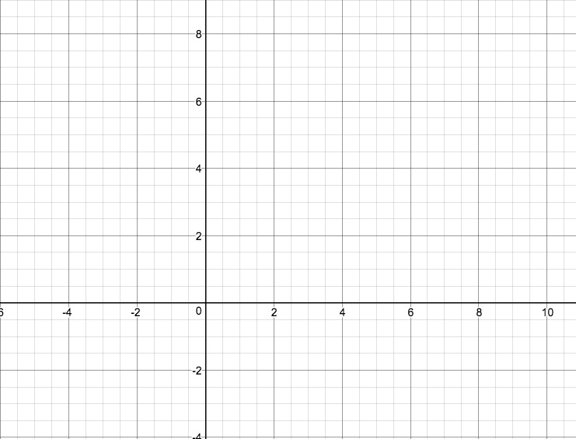

- y=$3({5)}^{x-2}$

