Exponential & Logarithmic function Review

1, At the start of 2005, Tristan’s father invested $500 his grandmother gave him for his birthday in an investment that doubles every seven years. In what year will he have $1,200 in his account?

2, Express$2\log_{3}{9+\log_{3}{7-\log_{3}{3}}}$ as a single logarithm.

3, Given $\log_{3}{x=-1 }$, the value of x is

4, Explain the steps to solve the equation $\log_{2}{\sqrt{x^{2}-8x}=}\log_{2}{3}$

5, Michelle is trying to determine the value of x in the equation $7^{x}=22$. Which one of the following will she use to obtain the value of x.

- $x=\log{(\frac{22}{7})}$

- $\log_{7}{x}=\log{22}$

- $x=\frac{\log{22}}{\log{7}}$

- $x=\frac{\log{7}}{\log{22}}$

6, The price of a particular product doubles every 35 years. If the price of the product was $16.40. On January 1, 1996, the price of the product will be $36.50 in the year ???

7, Solve the following equation for x: $\log_{5}{2x}-\log_{5}{3}=\log_{5}{4}$

8, Evaluate $\log_{5}{\sqrt[4]{125}}$

9, Solve: $\log_{x}{9}=\frac{3}{2}$

10, Compare to the graph of ${y=log}_{7}{x}$, describe the transformation of the function $y=\log_{7}\left(x-6\right)+7$

11, Use the laws of logarithms to write each of the following as a single logarithm.

a)$\log_{10}{x}-2\log_{10}{y}$ b) $3\log_{2}{x}+6\log_{2}{y}$ c) $\log_{3}{m}+\log_{3}{n}-\frac{1}{2}\log_{3}{p}$

d)$4\log_{5}{a}-\frac{1}{2}\log_{5}{b}$ e)$\frac{1}{2}\log_{10}{x}+\frac{1}{4}\log_{10}{y}$ f)$\log_{2}{9}+\log_{2}{7}$

g)$\log_{3}{(\frac{3}{7}})$ h)$2\log_{4}{6}$ i)$\log_{4}{2}-\log_{4}{8}$

k)$\log_{10}{\sqrt{27}}$ l)$\log_{a}{\frac{1}{b}}$

12, Solve the following logarithmic equation for the variable x

a)$\log_{4}{x=-4}$ b)$\log_{11}{x}=0$ c)$\log_{5}{x}=-4$

d)$\log_{10}{\sqrt[5]{10}}=x$ e)$\log_{6}{x}-\log_{6}{4}=\log_{6}{8}$ f)$\log_{10}{(x+2)}+\log_{10}{(x-1)}=1$

13, Use logarithms to determine the solutions to the following exponential equation, rounded to 1decimal place.

a)$3^{x}=32$ b)$4^{2x-2}=27$ c)$7^{x+1}={11}^{x}$

14,A radioactive element has a half-life of 120 years. Determine the length of time needed for an initial mass of 50g to decay to a final mass of 42g.

15, Write the following in exponential form

a)$\log_{2}{8=3}$ b)$\log{10000}=4$ c)$\log_{2}({\frac{1}{2}})=-1$

16, Sketch the graph of each function

a)${ y=log}_{3}{x}$

b)${y=log}_{3}{(x+4)}-3$

17, Identify the following characteristics of the graph of the function ${y=2log}_{5}{(x+5)}+6$
- Domain & Range
- X intercepts
- Y intercepts
- HA/VA??

18. Match the following functions with the given graphs

- ${y=log}_{8}{(2x)}$

- ${y=\frac{1}{3}log}_{2}{(x)}$

- $y=5\log{x}$

_____1,
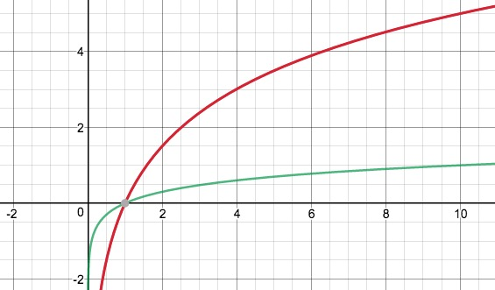

_____2,
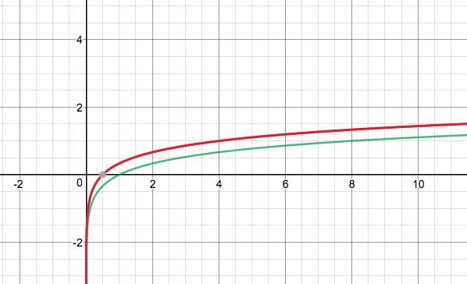

_____3,
